2)1-Creating Microservices for account and loan
Account:
AccountController.java:
package com.cognizant.account.controller;
import com.cognizant.account.model.Account;
import org.springframework.web.bind.annotation.*;
@RestController
public class AccountController {
@GetMapping("/accounts/{number}")
public Account getAccount(@PathVariable String number) {
return new Account(
number,
"Savings",
234343
);
}
}

Account.java:
package com.cognizant.account.model;
public class Account {
private String number;
private String type;
private double balance;
public Account() {
}
public Account(String number, String type, double balance) {
this.number = number;
this.type = type;
this.balance = balance;
}
public String getNumber() {
return number;
}
public void setNumber(String number) {
this.number = number;
}
public String getType() {
return type;
}
public void setType(String type) {
this.type = type;
}
public double getBalance() {
return balance;
}
public void setBalance(double balance) {
this.balance = balance;
}
}
AccountApplication.java:
package com.cognizant.account;
import org.springframework.boot.SpringApplication;
import org.springframework.boot.autoconfigure.SpringBootApplication;
@SpringBootApplication
public class AccountApplication {
public static void main(String[] args) {
SpringApplication.run(AccountApplication.class, args);
}
}
Output:
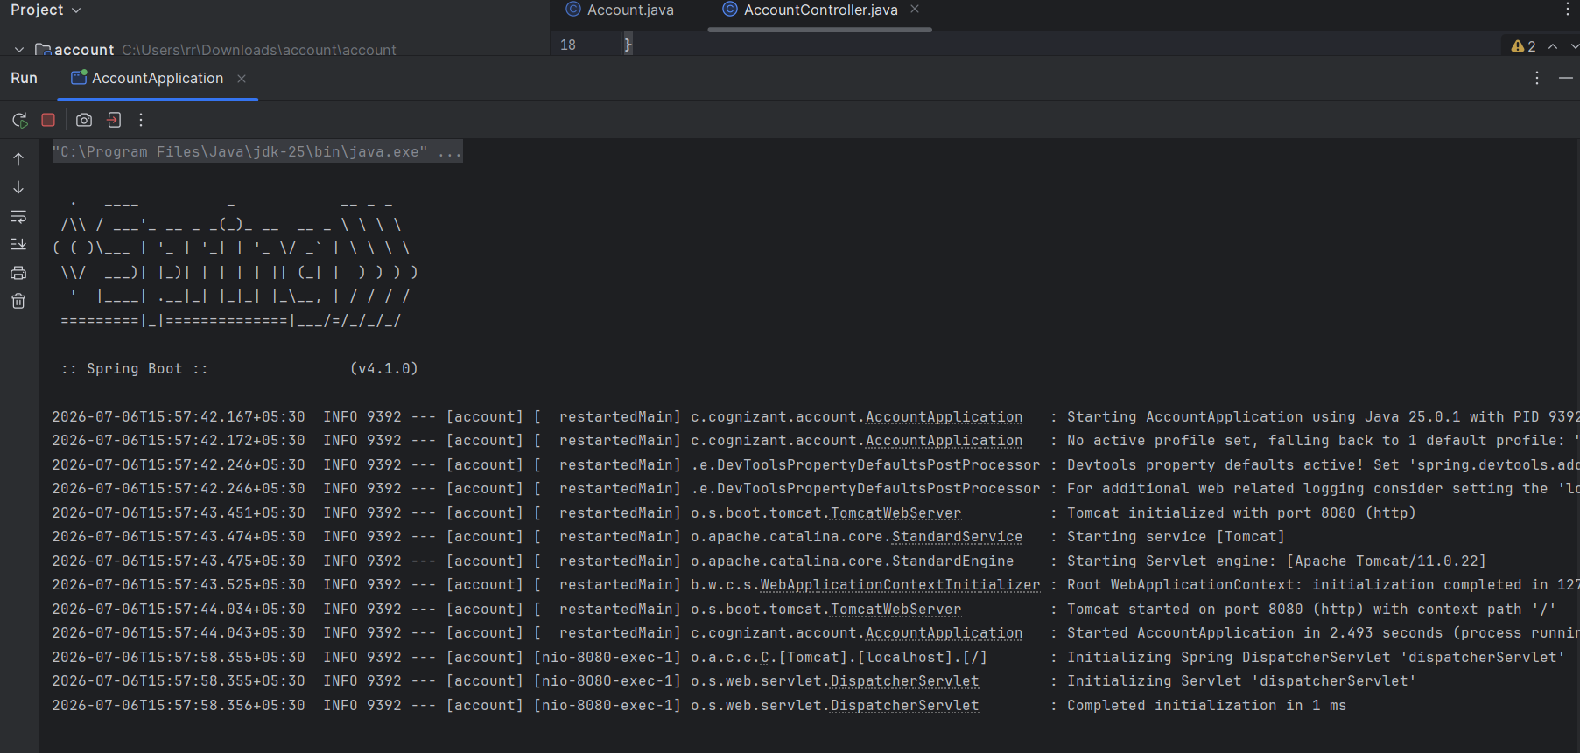

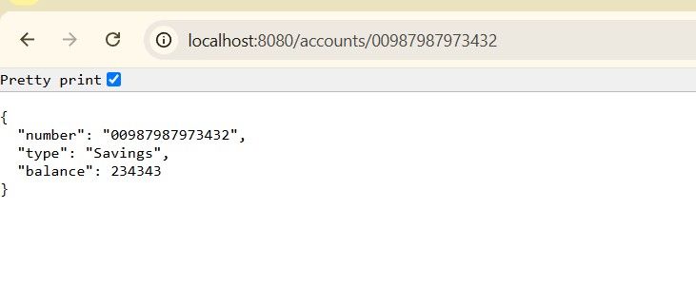
Loan
LoanController.java:
package com.cognizant.loan.controller;
import com.cognizant.loan.model.Loan;
import org.springframework.web.bind.annotation.GetMapping;
import org.springframework.web.bind.annotation.PathVariable;
import org.springframework.web.bind.annotation.RestController;
@RestController
public class LoanController {
@GetMapping("/loans/{number}")
public Loan getLoan(@PathVariable String number) {
return new Loan(
number,
"Car",
400000,
3258,
18
);
}
}

Loan.java:
package com.cognizant.loan.model;
public class Loan {
private String number;
private String type;
private double loan;
private int emi;
private int tenure;
public Loan() {
}
public Loan(String number, String type, double loan, int emi, int tenure) {
this.number = number;
this.type = type;
this.loan = loan;
this.emi = emi;
this.tenure = tenure;
}
public String getNumber() {
return number;
}
public void setNumber(String number) {
this.number = number;
}
public String getType() {
return type;
}
public void setType(String type) {
this.type = type;
}
public double getLoan() {
return loan;
}
public void setLoan(double loan) {
this.loan = loan;
}
public int getEmi() {
return emi;
}
public void setEmi(int emi) {
this.emi = emi;
}
public int getTenure() {
return tenure;
}
public void setTenure(int tenure) {
this.tenure = tenure;
}
}

LoanApplication.java:
package com.cognizant.loan;
import org.springframework.boot.SpringApplication;
import org.springframework.boot.autoconfigure.SpringBootApplication;
@SpringBootApplication
public class LoanApplication {
public static void main(String[] args) {
SpringApplication.run(LoanApplication.class, args);
}
}

application.properties:
spring.application.name=loan
server.port=8081

Output:
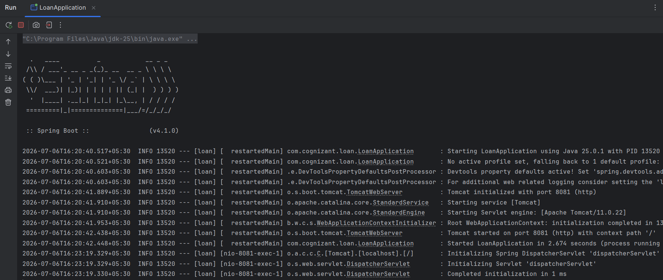

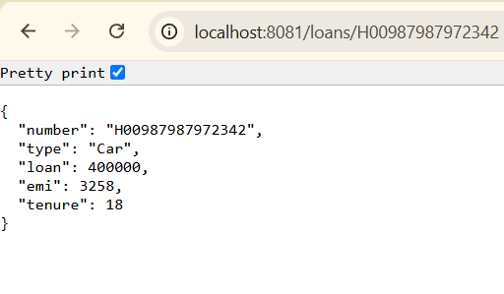

2)2-Create Eureka Discovery Server and register microservices
Eureka
LoanController.java:
package com.cognizant.loan.controller;
import org.springframework.web.bind.annotation.GetMapping;
import org.springframework.web.bind.annotation.RestController;
@RestController
public class LoanController {
@GetMapping("/loan")
public String loan() {
return "Loan Service Running";
}
}

LoanApplication:
package com.cognizant.loan;
import org.springframework.boot.SpringApplication;
import org.springframework.boot.autoconfigure.SpringBootApplication;
import org.springframework.cloud.client.discovery.EnableDiscoveryClient;
@SpringBootApplication
@EnableDiscoveryClient
public class LoanApplication {
public static void main(String[] args) {
SpringApplication.run(LoanApplication.class, args);
}
}

application.properties:
spring.application.name=loan-service
server.port=8082
eureka.client.service-url.defaultZone=http://localhost:8761/eureka

Output:
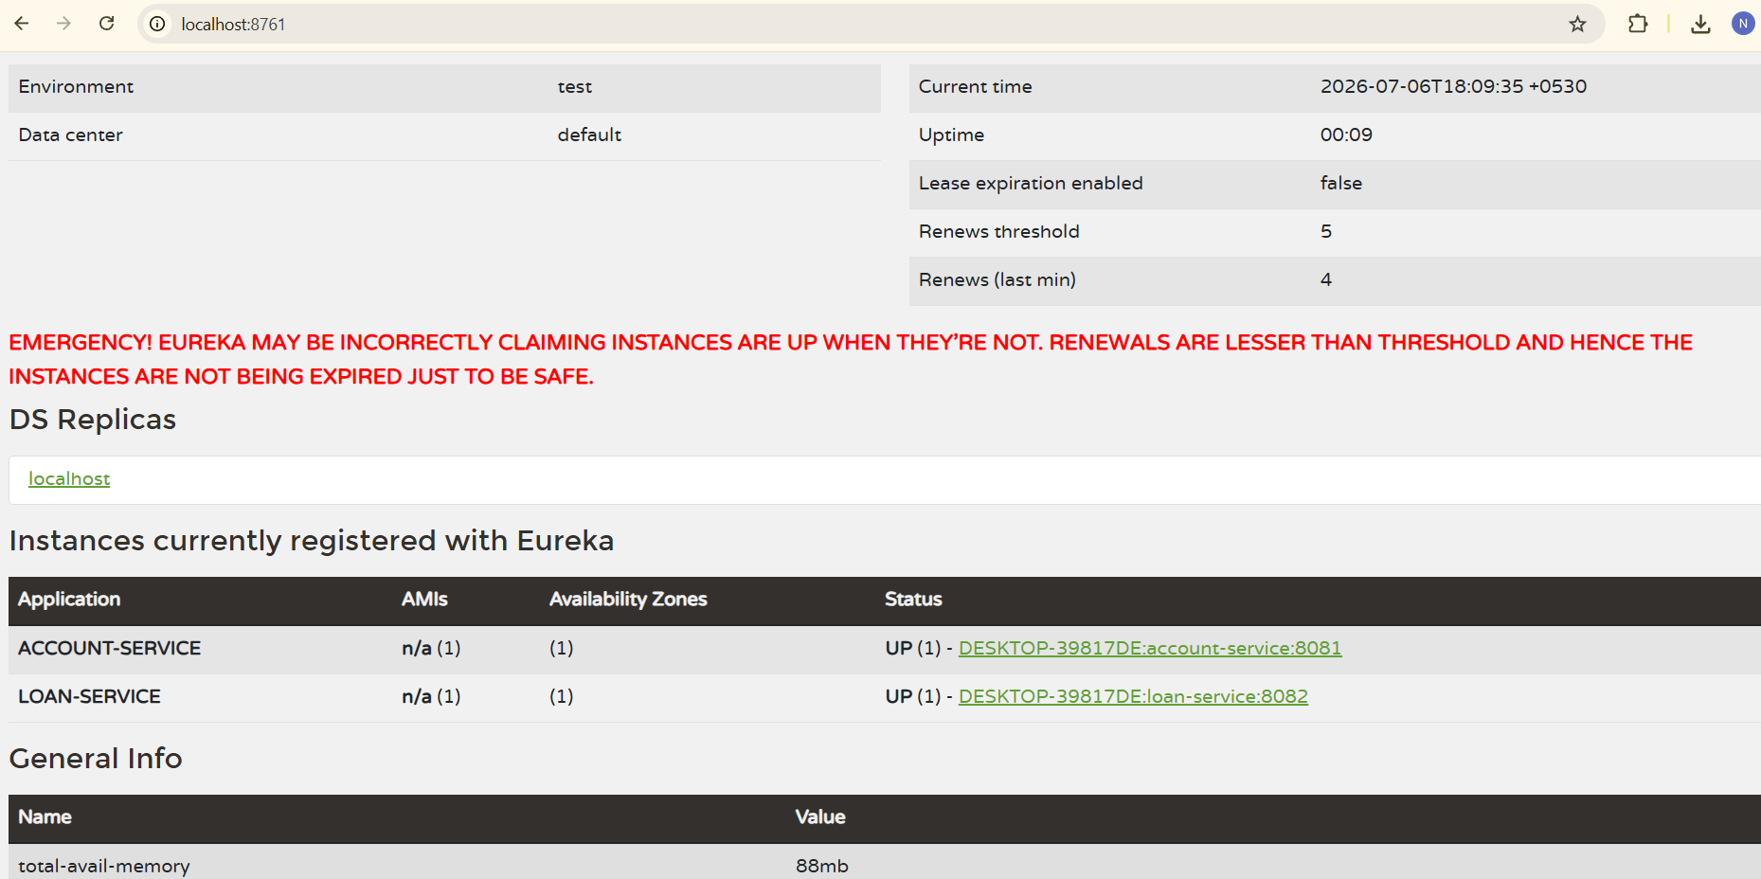

Account
AccountController.java:
package com.cognizant.account.controller;
import org.springframework.web.bind.annotation.GetMapping;
import org.springframework.web.bind.annotation.RestController;
@RestController
public class AccountController {
@GetMapping("/account")
public String account() {
return "Account Service Running";
}
}

AccountApplication.java:
package com.cognizant.account;
import org.springframework.boot.SpringApplication;
import org.springframework.boot.autoconfigure.SpringBootApplication;
import org.springframework.cloud.client.discovery.EnableDiscoveryClient;
@SpringBootApplication
@EnableDiscoveryClient
public class AccountApplication {
public static void main(String[] args) {
SpringApplication.run(AccountApplication.class, args);
}
}

application.properties:
spring.application.name=account-service
server.port=8081
eureka.client.service-url.defaultZone=http://localhost:8761/eureka

Output:
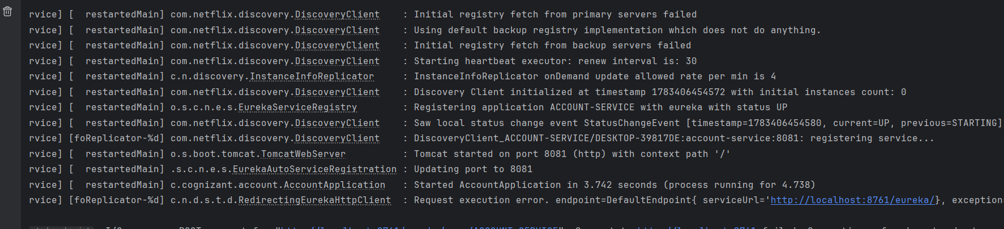
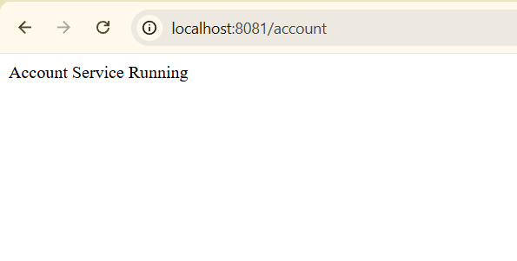
Loan
LoanController.java:
package com.cognizant.loan.controller;
import org.springframework.web.bind.annotation.GetMapping;
import org.springframework.web.bind.annotation.RestController;
@RestController
public class LoanController {
@GetMapping("/loan")
public String loan() {
return "Loan Service Running";
}
}

LoanApplication.java:
package com.cognizant.loan;
import org.springframework.boot.SpringApplication;
import org.springframework.boot.autoconfigure.SpringBootApplication;
import org.springframework.cloud.client.discovery.EnableDiscoveryClient;
@SpringBootApplication
@EnableDiscoveryClient
public class LoanApplication {
public static void main(String[] args) {
SpringApplication.run(LoanApplication.class, args);
}
}

application.properties:
spring.application.name=loan-service
server.port=8082
eureka.client.service-url.defaultZone=http://localhost:8761/eureka

Output:

